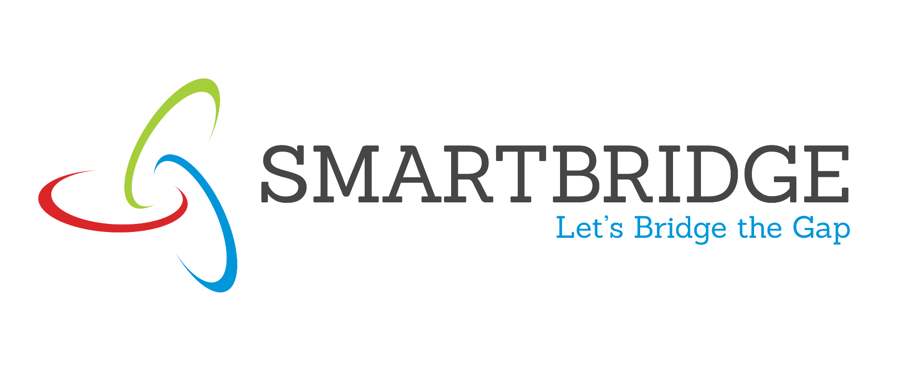 | 
Scalability & Future Plan
Date | 10 July 2026
Team ID
Project Name | Smart Agricultural Production Optimization Engine (OptiCrop)
Maximum Marks | 1 Mark
Scalability & Future Plan:
This document outlines how the OptiCrop solution can be scaled to handle larger user bases, increased data loads, or extended features in the future. It also captures the team's roadmap for enhancing and evolving the project beyond its current state.
Current System Limitations:
S.No | Limitation | Impact | Priority to Address (High / Medium / Low)
1 | The model is trained on a general crop dataset and may not generalize well to highly localized or unusual soil conditions. | Reduced recommendation accuracy for uncommon regional soil profiles. | Medium
2 | The Flask development server is single-threaded and not production-grade. | Limits the number of concurrent users the system can serve reliably. | High
3 | There is no persistent database; user submissions are not stored. | No history tracking, trend analysis, or personalization over time. | Medium
Scalability Plan:
S.No | Scalability Aspect | Current State | Proposed Upgrade / Solution
1 | User Load | Single Flask development server; comfortably handles up to ~50–100 concurrent users in testing. | Deploy behind Gunicorn with multiple workers and an Nginx reverse proxy; containerize with Docker for horizontal scaling under a load balancer.
2 | Data Storage | Training dataset is a static CSV file; the trained model is loaded into memory at startup. | Migrate to a managed database (e.g., PostgreSQL) to store user submissions, historical predictions, and versioned training datasets.
3 | Performance | Average response time of 1.3 seconds under moderate load (see Performance Testing document). | Add response caching for repeated inputs and batch inference where possible to reduce per-request overhead as usage grows.
4 | Security | Basic input range validation on soil and climate parameters. | Add API key or JWT-based authentication, request rate limiting, and enforce HTTPS for any public deployment.
Future Roadmap:
Phase | Planned Feature / Enhancement | Target Timeline | Expected Impact
Phase 1 | Multi-language support for regional farmers | Q3 2026 | Wider adoption among non-English-speaking farmers
Phase 2 | Persistent database and user accounts to track submission history | Q4 2026 | Enables personalized, history-aware recommendations over time
Phase 3 | Mobile app or SMS-based interface for low-connectivity areas | Q1 2027 | Extends reach to farmers without smartphones or reliable data access
Phase 4 | Integration with satellite or weather APIs for real-time climate data | Q2 2027 | Improves recommendation accuracy using live environmental conditions

